Big Mountain Resort Project Summary

Big Mountain Ski Resort (BM) is seeking a data based approach to predict their ticket prices to maximize revenue and also recoup increased operating costs from adding a chair lift. Previously, BM marked up above the average price in their market segment. This method was suspected to not maximize the value of its facilities. Hence, a predictive model was developed which considered information about resort facilities as well as pricing of all resorts in the ski market segment and recalculated a new price for BM based on a number of modeling scenarios.

The pre-model ticket price charged by BM was $81. Running the model, the new predicted price is $95. It is possible that BM may be underpricing as well as resorts under or over pricing which factor into this new model price.

Some modeling scenarios and corresponding recommendations are discussed below:

# Recommendations

1. **Closing up to 10 runs**

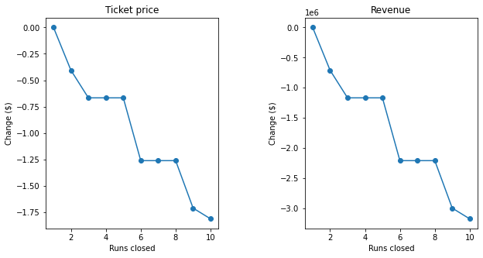

As seen from the above plots, closing runs progressively reduces the ticket price and thus revenue. Closing 1 run does not affect ticket price, closing 2,3 runs drops the price while there is no price change between closing 3-5 runs.

Closing a single run could be a strategy tested by the business as it does not affect ticket price. It could help reduce any run related costs such as maintenance and thus help increase its profit. This information can be more clear with data available for feature related operating costs.

1. **Adding a run, increase vertical drop and add a chair lift**

Vertical drop was an important feature seen to affect the model. Under the scenario mentioned above, increasing the vertical drop by 150 feet supports raising ticket price by $1.99 and subsequent revenue by $3,474,638. Following is a plot for ticket price and increase in vertical drop with the same additional run and chair lift. Increasing vertical drop is positively correlated with ticket price and thus revenue. Other constraints which include costs for increasing vertical drop would need to be considered to decide on the optimum amount of increase in vertical drop.

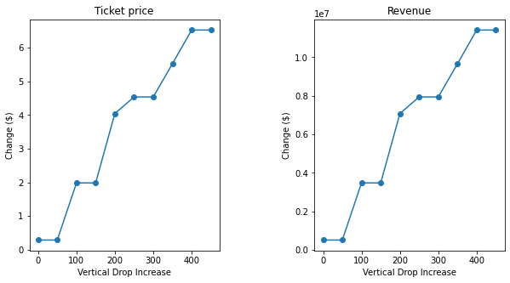

1. **Repeating 2. above and adding 2 acres for snow making**

Adding 2 acres of snow making cover does not boost the ticket price beyond the scenario above. This method may not be helpful to raise prices based on the model. Looking at a histogram for snow making area cover for all resorts, BM is already very high on this list as seen below. Hence increasing it further may not impact the model by a lot.

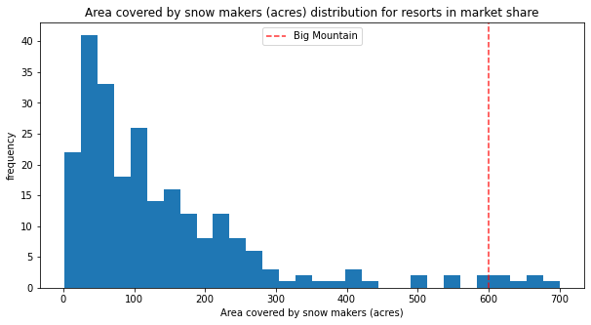

1. **Increase longest run by 0.2 mi and cover an additional 4 acres for snow making**

This scenario did not make any difference to the ticket price. Longest run as a feature was not very important in the current model. Also similar to above, BM already was very high in the longest run feature comparison against other resorts.

Conclusion:

Looking at these scenarios, reducing runs by 1 and increasing vertical drop could be a strategy tested by Big Mountain for a higher ticket price. To cover additional operating costs from an additional chair lift, a $0.88 increase per ticket will be needed assuming 350,000 people visit the resort and on average, each person buys 5 tickets. Scenario 2 supports a price increase of $2 which will help cover these costs. As mentioned then, costs related to increasing the vertical drop should also be considered to calculate final profits.